Short questions
Name
Institution
Date

Short questions
Question one
Covid-19 has adversely affected the ocean freight industry. One of the effects the pandemic has had on ocean freight is a decrease in the volume of goods being shipped through the sea. When the pandemic struck, ocean sailers were quick to respond by removing shipping capacity from the market (Agility, 2020). This led to canceled sailings and the elimination of strings.
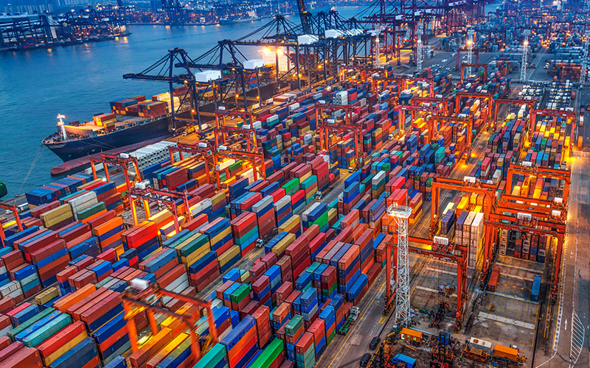
Agility. (2020). 4 Big Logistics Challenges of COVID-19 – and How to Overcome Them. Retrieved from: https://logisticsinsights.agility.com/COVID19/4-big-logistics-challenges-of-covid-19-and-how-to-overcome-them/
Question two
Almonds have a variety of uses, including lowering cholesterol, skincare purposes, remedying anemia, and inhibiting the growth of cancer cells. It is important to note that even though almonds have been proven to effective in curing pain and spasms when taken in excess amounts, they can lead to poisoning because they contain hydrocyanic, which can result in breathing problems, choking, nervous breakdown, and death (TNN, 2020). When the product is broken down, almonds are used to manufacture almond milk which is nutritious for the body.
TNN. (2020). Surprising side effects of eating too many almonds. Retrieved from: https://timesofindia.indiatimes.com/life-style/health-fitness/photo-stories/5-surprising-side-effects-of-eating-too-many-almonds/photostory/60747918.cms
Question three
The product I settled on is McDonald’s French Fries. Interestingly, McDonald’s French Fries differ in sizes and ingredients used when in the United States and while in the United Kingdom. In the United States the ingredients used to make McDonald’s French Fries include canola oil, potatoes, vegetable oil, corn oil, soybean oil, dextrose, citric acid and dimethylpolysiloxane while in the United Kingdom only four ingredients are used to make the McDonald’s French Fries namely vegetable oil, potatoes, dextrose and salt. The McDonald’s French Fries sold in the United States have approximately 40 more calories than those sold in the United Kingdom. In the United States the sizes of McDonald’s French Fries served are larger than in the United Kingdom. The factor that the company might have considered is compliance. The most difficult factor for a company is compliance because they have to consider the set standards of their products from the get go in order to ensure they meet all the requirements. The phrases I would use for a business meeting in the United Kingdom is due diligence and streamline. I decided on these phrases because they are necessary to show business etiquette. The phrases will aid in the negotiation process during the business meeting.
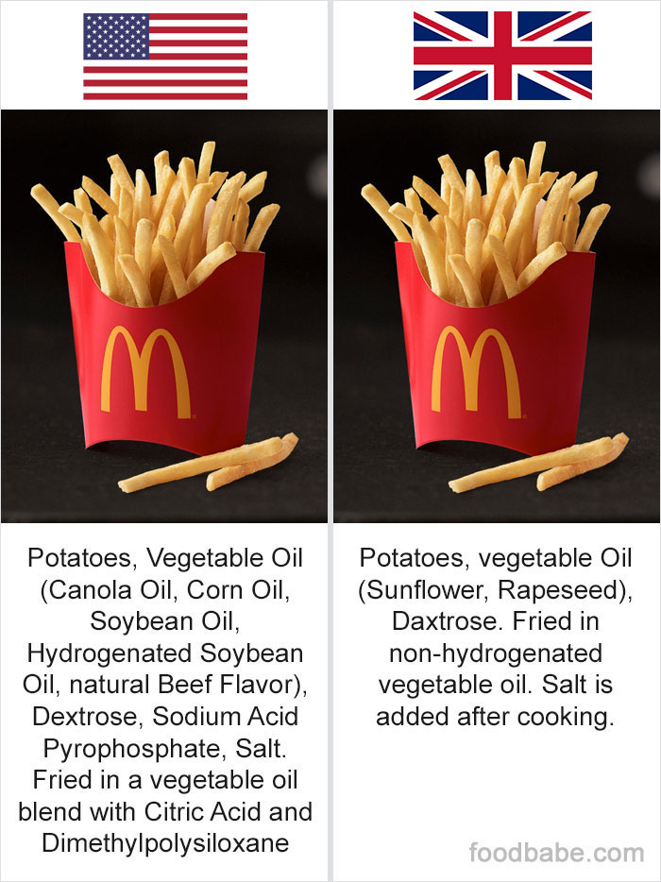
https://www.demilked.com/uk-vs-us-food-differences-food-babe/

References
Agility. (2020). 4 Big Logistics Challenges of COVID-19 – and How to Overcome Them. Retrieved from: https://logisticsinsights.agility.com/COVID19/4-big-logistics-challenges-of-covid-19-and-how-to-overcome-them/

TNN. (2020). Surprising side effects of eating too many almonds. Retrieved from: https://timesofindia.indiatimes.com/life-style/health-fitness/photo-stories/5-surprising-side-effects-of-eating-too-many-almonds/photostory/60747918.cms

